Rajshahi University of Engineering & Technology
Department of Computer Science of Engineering

Experiment No: 01
Name of Experiment: Complexity of Algorithms

Submitted to:

Rizoan Toufiq
Assistant Professor
Department of Computer Science & Engineering
Rajshahi University of Engineering & Technology

Submitted by:

Name: Md. Ariful Islam
Roll No.: 1803046
Group: 2nd Thirty
Date of Exp.: 01-09-2019
Date of sub. : 08-09-2019
Series: 18

Machine configuration:
Asus X510uf

core i5 8th Generation
8gb Ram
Win 10 OS

Theory: Algorithm complexity is a measure which evaluates the order of the count of operations, performed by a given or algorithm as a function of the size of the input data. Complexity is a rough approximation of the number of steps necessary to execute an algorithm. It can be Time Complexity or can be Space Complexity.

Big-O Notation: f(n) is O(g(n)) if and only if there exist two constants c and n0such that |f(n)| < c|g(n)| for all n>no. f(n) will normally represent the computing time of some algorithm. When we say that the computing time of an algorithm is O(g(n)) we mean that its execution takes no more than a constant times g(n). n is a parameter which characterizes the inputs and/or outputs. For example n might be the number of inputs or the number of outputs or their sum or the magnitude of one of them.

Problem 1 : Finding the Complexity of a Loop.

Algorithm: Step 1. Repeat for K = 1 to n by 1

Step 2. Write: K

[End of Step 1 loop]

Step 3. Exit

Code:

#include<stdio.h>

int main()

{

int k,n,count=0;

scanf("%d",&n);

for(k=1;k<=n;k++)

{

printf("K ");

count++;

}

printf("\n%d",count);

return 0;

}

Complexity Analysis: The computing time of the loop, f(n) = n. So the complexity of the above algorithm is O(n). Here f(n)≤cg(n), c =2, n0 = 0, g(n) = n.

Complexity Table:
N | f(n) (From Program) | cg(n)
5 | 5 | 10
10 | 10 | 20
15 | 15 | 30
20 | 20 | 40

Graph:

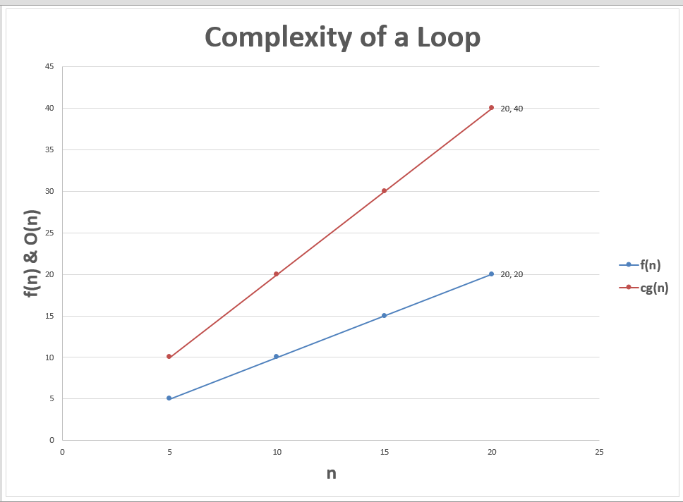

Problem 2: Finding the Complexity of the following Program.

Algorithm:
Step 1. Repeat for K = 1 to n by 1
Step 2. Repeat for L = 1 to n by 1
Step 3. Write: L
[End of Step 2 loop]
Step 4. Write: K
[End of Step 1 loop]
Step 5. Exit
Code:

#include<stdio.h>

#include<math.h>

int main()

{

int k,l,n,c=0;

scanf("%d",&n);

for(k=1;k<=n;k++)

{

for(l=1;l<=n;l++)

{

printf("L ");

c++;

}

printf("K ");

c++;

}

printf("\n%d",c);

return 0;

}

Complexity Analysis: The computing time of the loop, f(n) = (n² + n), So the complexity of the above algorithm is O(n²). (Let c= 2)

Complexity Table:
N | f(n) (From Program) | cg(n)
5 | 30 | 50
10 | 110 | 200
15 | 240 | 450
20 | 420 | 800

Graph:

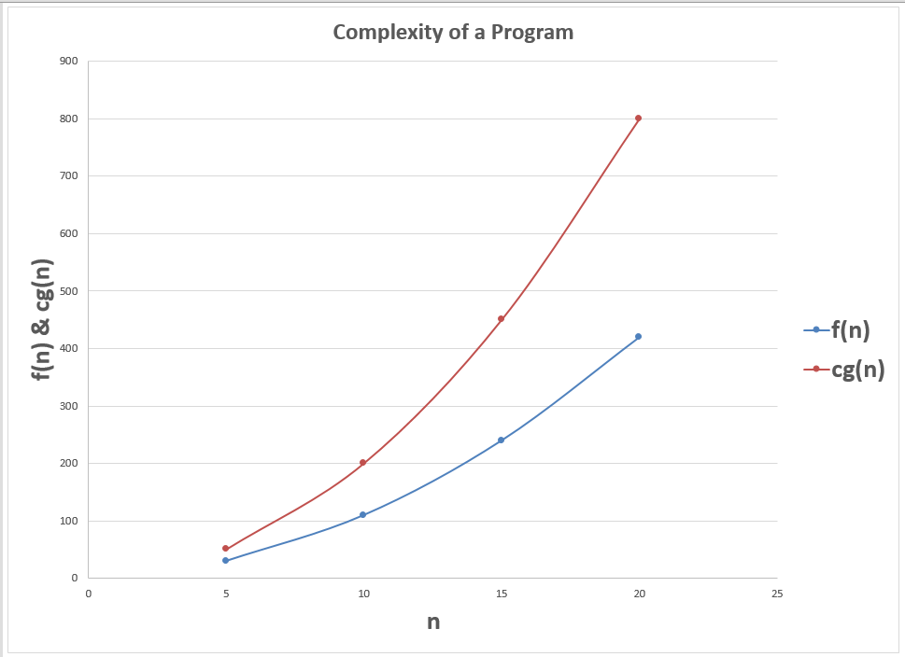

Problem 3: Find the Complexity of the elementary Sort algorithm.

Algorithm: (Given a nonempty array A with n numerical values. This algorithm sorts the values)
Step 1. Repeat for i = 2 to n by 1
Step 2. Repeat for k = i to 1 by -1
Step 3. If A[k]<A[k-1] then:
Swap (A[k], A[k-1])
[End of If Structure]
[End of Step 2 loop]
[End of Step 1 loop]
Step 4. Exit

Code:

#include<stdio.h>

int main()

{

int a,i,k,c=0,n,A[20]={14,56,31,57,87,11,7,23,42,2,45,78,93,91,79,81,9,63,37,1};

scanf("%d",&n);

for(i=1;i<n;i++)

{

for(k=i;k>=0;k--)

{

if(A[k]<A[k-1])

{

a=A[k];

A[k]=A[k-1];

A[k-1]=a;

c++;

}

c++;

}

c++;

}

printf("%d",c);

return 0;

}

Complexity Analysis: The complexity of the above algorithm is O(n2). (Let c= 2).

Complexity Table:
N | f(n) (From Program) | cg(n)
5 | 23 | 50
10 | 100 | 200
15 | 183 | 450
20 | 336 | 800

Graph:

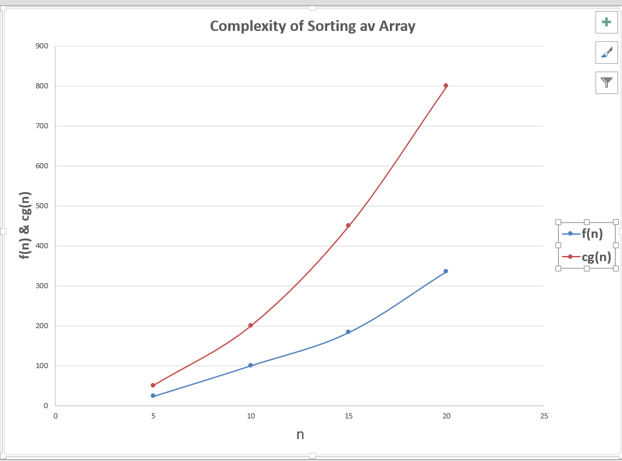

Problem 4: Finding the largest element in Array.

Algorithm: (Given a nonempty array A with n numerical values. This algorithm finds the location LOC and the value MAX of the largest element of A)
1. Set K:=1, LOC:=1 and MAX:=A[1]
2. Repeat steps 3 and 4 while K≤n
3. IF MAX < A[K] then:
Set LOC:=K and MAX:=A[K].
[End of If structure]
4. K:=K+1.
[End of step 2 loop]
5. Write: LOC, MAX.
6. Exit

Code:

#include<stdio.h>

int main()

{

int k=1,l=1,A[10]={14,56,31,57,87,11,7,23,42,2};

int m=A[0];

while(k<10)

{

if(m<A[k])

{

m=A[k];

l=k+1;

}

k++;

}

printf("\nLOC: %d MAX: %d\n",l,m);

return 0;
}

Output:
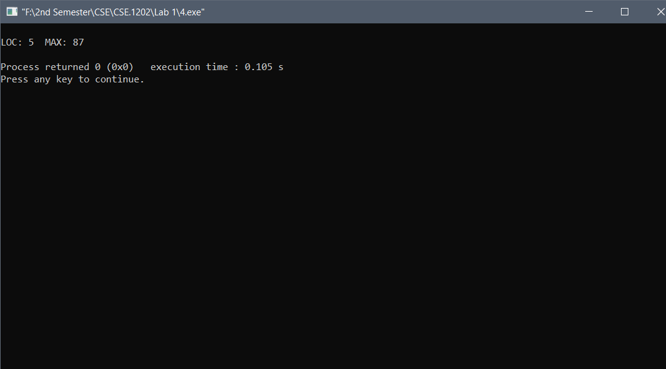

Problem 4: Linear Search.

Algorithm: (Given a nonempty array A with n numerical values and a specific x of information is given. This algorithm finds the location LOC of x in the array A or Sets LOC=-1)
1. Set K:=1, LOC:=-1
2. Repeat steps 3 and 4 while LOC = -1 and K≤n
3. IF x = A[K] then:
Set LOC:=K. [End of If structure]
4. K:=K+1.
[End of step 2 loop]
5. If LOC = -1 then: Write: x is not in the array A.
Else: Write: LOC is the location of x [End of If structure]
6. Exit

Code:

#include<stdio.h>

int main()

{

int k=0,l=-1,x,A[10]={14,56,31,57,87,11,7,23,42,2};

scanf("%d",&x);

while(l==-1&&k<10)

{

if(x==A[k])

l=k+1;

k++;

}

if(l==-1)

printf("\n%d is not in the array A.\n",x);

else

printf("\n%d is the location of %d\n",l,x);

return 0;
}

Output:
